MS Excel: VLOOKUP and Advanced Printing
Lesson Plan
Rev. 7/2018

Introduction
- Introductions
- Housekeeping

Class Learning Objectives
By the end of this class, you will be able to:
- Print a spreadsheet or a custom print area
- Use the VLOOKUP function

Printing

Open the Advanced Formatting worksheet.

Print Preview
- Before you print any document, make sure it is going to look the way you expect.
- With Excel, there is much to consider.
  - Large workbooks won’t fit on a single sheet of paper.
  - Many won’t even fit in a single column of pages going down.
- You can see how your file will print in case adjustments need to be made.
Perform Print Preview
- Click on File tab then choose Print.
  - This spreadsheet obviously doesn’t fit on one page.
  - Scroll through several pages to show how the information displays.
  - We lose context for some of the numbers – headers are lost after the first page
  - We need to give Excel more information on how to print the file.
Print Titles (Adding row and column headers to each printed page)
- Let’s say we print this report every day and if we drop it, we have no way of knowing the page order or which version of the report we have.
- We need to give Excel more information to print the file the some useful information about the file.
- Close Print Preview using the Arrow button in top left corner

Let’s repeat rows at the top and columns to the left.
- Click on Print Titles on the Page Layout tab.
- On the Sheet tab, under Print titles, click in the field for ‘Rows to repeat at top.’
- Click on the header for Row 1.
- Click in the field for ‘Columns to repeat to left.’
- Click on the column header for column A.
- Click on Print Preview button at bottom of dialog box.
- Scroll through several pages.
- We have a context for the numbers on the page.
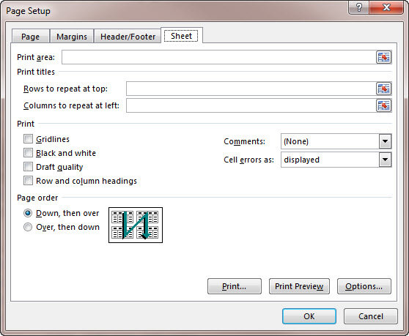
- But! If you scroll through the pages, you’ll see that there is some information related to 3M Company on page 1, but then we see more information all the way over on page 12. We probably want these two pages to be one right after the other.
- Let’s tell Excel the page order.
- Close Print Preview
  - Use the Arrow button in top left corner.

Set Print Page Order
- Click on Print Titles on the Page Layout tab.
- On the Sheet tab in the Page Order section, click on Over then Down.
- Click on Print Preview button at bottom of dialog box.
- Scroll through several pages.
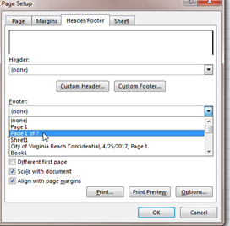
- Now we see that all the information about 3M Company is printed one page right after another. Yay!
- Close Print Preview using arrow in top left corner.

Page Numbers and Footers
- Click on Print Titles again in Page Layout tab.
- Click on Header/Footer tab in the dialog box
and in the dropdown menu for footer to select Page 1 of ?.
- But what if we print this report daily? Would it be useful to have more information, like the date printed or the file name?
- On the Header/Footer tab, click on Custom Footer.
- In the LEFT section, type “Printed on” and then click Insert Date button (looks like a calendar)
- In the RIGHT section, click Insert File Name (Excel icon)
- Click on Print Preview button at bottom of dialog box.
- Revel in the awesome changes made to the document on every page.
- Close Print Preview.

Set Print Area
- If you need a quick print or to print a small area of a larger worksheet, you can use the PRINT AREA function to choose what to print.
- Select a block of cells
- Go to Page Layout tab and choose PRINT AREA in Page Setup group
- Choose SELECT PRINT AREA
- Go to File Tab and select Print (or use CTRL+P) to preview what will be printed
- To clear your selection, go back to PAGE LAYOUT tab, PRINT AREA and choose CLEAR PRINT AREA.

VLOOKUP Function
- Watch the VLOOKUP video from Exceljet.com (3:10): https://exceljet.net/tips/how-to-use-vlookup

- Explanation: If your information is laid out in columns and you want Excel to look up information up and down the columns, you’ll need to use a VLOOKUP function. The “v” in the function is an abbreviation for vertical.

Some Tips:

  - VLOOKUP requires that the table of data is structured.
    - The lookup values should appear in columns to the left
    - The data that you’re trying to retrieve appear in columns to the right.

  - Keep in mind that VLOOKUP will match the first value only.
    - So, if you have a table with duplicates, then you will only get the first value.

  - Make sure to sort your table of information in ascending order.

There are more tips on Exceljet.net.

4 VLOOKUP Arguments
- Lookup_value: the value you’re trying to lookup. An example is an id number or someone’s name.
- Table_array: the table or range where you want to lookup the value
- Col_index_number the column number in the range that will have the return value
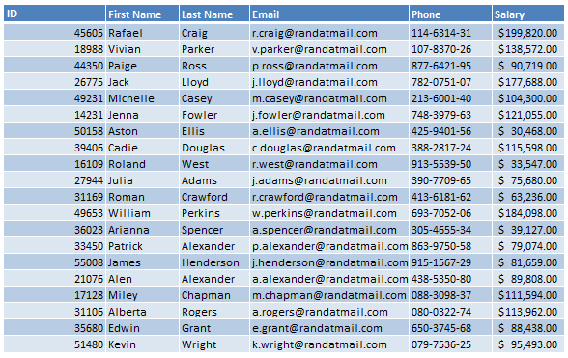
1
2
3
4
5
6
- [range lookup]

Approximate match as indicated by 1/True (default setting)
OR Exact match as indicated by 0/False

Lookup information in various columns using VLOOKUP
- In the class file, go to the VLOOKUP Function worksheet
- Highlight cell range C5:H24
- Go to the Formulas tab. In the Defined Names group, click on the Define Name dropdown and choose Define Name.
- Change the Scope to VLOOKUP Function.
- Enter dataX as the name and click Ok. Naming cells or ranges will make our function easier to read. Also, it will turn cells and ranges into an absolute references. This will allow us to easily copy the formula.
- Select cell C2 and open up the Define Name dialog box again. Name this cell idX.
- You will now be entering the function into the worksheet. Follow along with the instructor. The formula should look like this in cell D2: =VLOOKUP(idX,dataX,2,FALSE).

Translation:
This means that we will look up whatever id number that we’ve typed in cell C2 within the Data range. We will retrieve the first name that’s in column number 2. We have set the range lookup to False so that we get an exact match and not an approximate match.

Now, we will use the fill handle to copy this function across so that we can get the other missing values. However we need to correct the functions after they’ve been copied over. We’re getting the same values because we used absolute cell references. Remember, when you name a cell or cell range, it will become an absolute cell reference in any formulas that use it.

- Select cell D2, hover the mouse over the lower right corner until it turns into the black cross. This is your fill handle. Drag it across to cell range E2:H2.
- In cell E2, change the column number to 3.
- In cell F2, change the column number to 4.
- In cell G2, change the column number to 5.
- In cell H2, change the column number to 6.

Lookup information from one worksheet, then use it in another worksheet.
- Go to the VLOOKUP Part 2 worksheet.
- Select cell D5 and type =VLOOKUP(C5,'Vlookup Function'!dataX,6,0)
- Use your fill handle and copy the function down the column. You can do this quickly by double clicking on the fill handle.

Wrap Up
- Class review
- Questions?
- Resources for learning more:
  - Technology page – www.vbgov.com/tech-ed (also under Adults)
    - Upcoming classes
    - Tech Help service information
    - Teach Yourself Technology
  - Exceljet.net
  - Lynda.com demonstration
  - Go to VBPL website: www.VBgov.com/libraries -> Digital Library -> Learn
  - You will need to complete a one-time account setup with their name and email address
    - Subsequent access will be via our library website and login will just be their library card number and PIN
  - Browse or search topics
  - Use filter options on the left side of page to narrow results by skill level and subject
  - Use + button to add courses to your playlist, your progress will be saved.
  - Certificates of completion at end of most courses.
- Google search – for text-based or video instructions
- Homework:
- Practice using the outline and practice file from class! Save to a USB drive prior to leaving.
- Please complete the evaluation – your anonymous feedback is appreciated!
- Thank you for your time and for attending this class!

This work, “Micrsoft Excel: Analyzing Data," is a derivative of "Microsoft Excel: Advanced Formatting" and “Microsoft Excel: Charts and Pivot Tables” by the Denver Public Library, used under CC BY. "Micrsoft Excel: Analyzing Data” is licensed under CC BY by Virginia Beach Public Library.

